ELIGIBILITY REVIEW COMMITTEE
ROSTER 2013-14

COMMITTEE MEMBER TERM

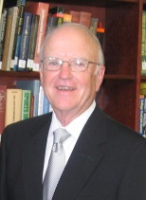
CHAIR
Garry D. Hays 2008-2014
President Emeritus
United States International University (now part of Alliant International University)

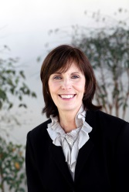
Stephanie Bangert 2011-2014
Executive Director, Office of the President
Samuel Merritt University

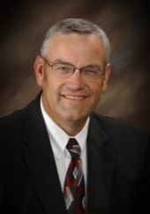
Max L. Checketts 2012-1015
Vice President for Academics
Brigham Young University-Hawaii

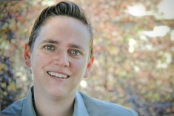
Melanie Corn 2011-2014
Provost
California College of the Arts

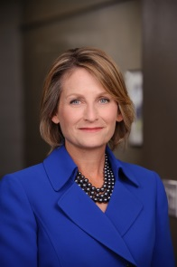
Bethami A. Dobkin 2010-2016
Provost and Vice President for Academic Affairs
Saint Mary’s College of California

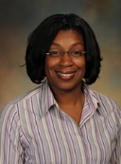
Dawn Eastmond 2009-2016
Director of Graduate Education
Kellogg School for Science and Technology
The Scripps Research Institute

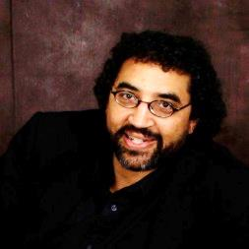
Aubyn Fulton 2011-2014
Professor of Psychology
Pacific Union College

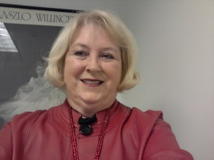
Andrea Helekar 2011-2014
Director of Institutional Research
Fashion Institute of Design &Merchandising

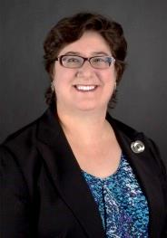
Susan Keller 2011-2014
Associate Dean for Academic Affairs and Professor of Law
Western State College of Law at Argosy University

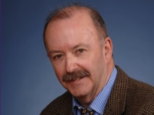
Neal King
President 2011-2014
Institute of Transpersonal Psychology

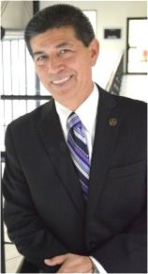
Fernando Leon Garcia 2012-2015
President
CETYS University

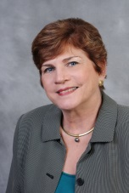
Nancy Lewis* 2013-2016
Director, Research Programs, East West Center

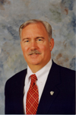
Greg O’Brien* 2013-2016
President
The Higher Education Group, Inc.

Patricia E. Potter 2012-2015
President, retired
National University

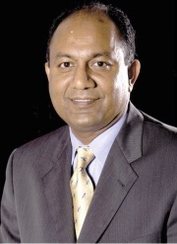
John Thomas 2012-2015
Dean of the Zapara School of Business
La Sierra University

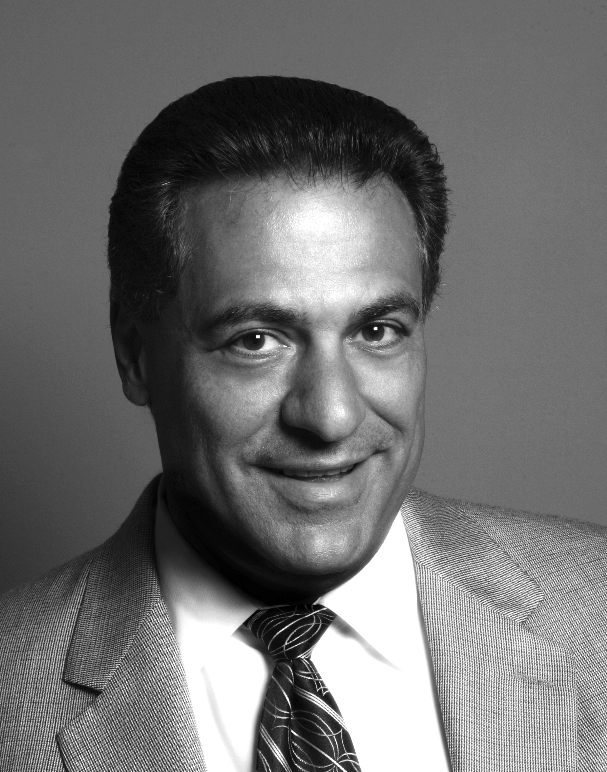
Joe Vollaro 2012-2015
Executive Vice President of Financial Aid & Compliance
Academy of Art University

